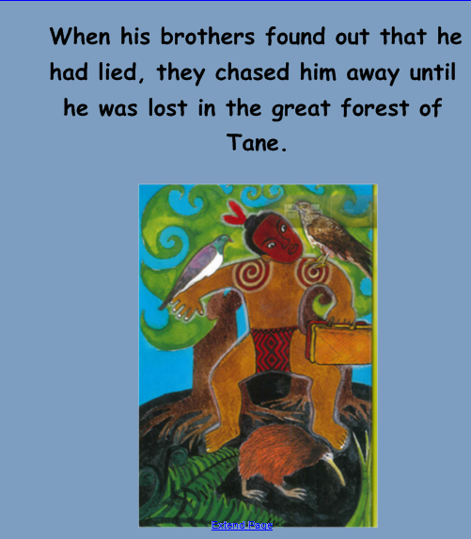
This is a page off our Digital Story – “Hatupatu and the Bird Woman”

